**xPression 4.7 - Installation and upgrade approach**

**Long Term Care Group**

**12/03/2019**

**Table of Contents**

1. Configuration Essentials 3

2. Upgrade SQL Server DB 5

3. Install Java 7

4. Install JBOSS 11

5. Install SQL server driver 16

6. Install xPression server 19

7. Running as a windows service 45

8. Update files: 46

9. Access requests on the Servers 51

10. License key update 52

11. Specific Fonts to be Installed 55

12. Shared folders 55

13. Issues: 57

14. Issues encountered during Installation and Resolution: 59

15. Templates: 65

16. New Changes from 4.5: 66

17. xDesign installation 67

xAdmin URLS 82

# Configuration Essentials

|  |  |
| --- | --- |
| **xPression Version** | 4.7 |
| **Hot Fixes or Service Packs** | Latest |
| **Application Server** | JBOSS 7.2.0 |
| **Operating System** | Windows 2016 Server 64-bit |
| **Application Server Cluster** | N/A |
| **Name/IP of machines** | DC2APP1081D |
| **Database Server** | SQL Server 2016 |
| **Operating System** | Windows 2016 Server 64-bit |
| **Database Cluster** | N/A |
| **Name of machine** | DC2SQL1081D |
| **Customer data source(s)** | XML |
| **Customer Environment** | **DEV** |
| **xPression Design** | DC2APP1082D |
| **Operating System** | Windows 2016 Server 64-bit |
| **Connectivity to server** | xDesign will be installed on the client’s desktops and DC2APP1082D |
| **Connectivity method** | Servlet |

|  |  |
| --- | --- |
| **xPression Version** | 4.7 |
| **Hot Fixes or Service Packs** | Latest |
| **Application Server** | JBOSS 7.2.0 |
| **Operating System** | Windows 2016 Server 64-bit |
| **Application Server Cluster** | N/A |
| **Name/IP of machines** | DC2APP1081T |
| **Database Server** | SQL Server 2016 |
| **Operating System** | Windows 2016 Server 64-bit |
| **Database Cluster** | N/A |
| **Name of machine** | DC2SQL1081T |
| **Customer data source(s)** | XML |
| **Customer Environment** | **TEST** |
| **xPression Design** | DC2APP1082D |
| **Operating System** | Windows 2016 Server 64-bit |
| **Connectivity to server** | xDesign will be installed on the client’s desktops and DC2APP1082D |
| **Connectivity method** | Servlet |

|  |  |
| --- | --- |
| **xPression Version** | 4.7 |
| **Hot Fixes or Service Packs** | Latest |
| **Application Server** | JBOSS 7.2.0 |
| **Operating System** | Windows 2016 Server 64-bit |
| **Application Server Cluster** | N/A |
| **Name/IP of machines** | DC1APP1081P |
| **Database Server** | SQL Server 2016 |
| **Operating System** | Windows 2016 Server 64-bit |
| **Database Cluster** | N/A |
| **Name of machine** | DC1SQL1081P |
| **Customer data source(s)** | XML |
| **Customer Environment** | **PROD** |
| **xPression Design** | DC2APP1082D |
| **Operating System** | Windows 2016 Server 64-bit |
| **Connectivity to server** | xDesign will be installed on the client’s desktops and DC2APP1082D |
| **Connectivity method** | Servlet |

# Upgrade SQL Server DB

Please create a new database,DC2SQL1081D.. DEV1XPRESS, from the source database MNEPSQL1000D.. DEV1XPRESS.

Please create a new database,DC2SQL1081T..TST1XPRESS, from the source database MNEPSQL1000T..TST1XPRESS.

Please create a new database,DC1SQL1081P.. PRD1XPRESS, from the source database MNEPSQL1000P.. PRD1XPRESS.

Please assure the access on DC2SQL1081D.. DEV1XPRESS is the same as the source database MNEPSQL1000D.. DEV1XPRESS

Please assure the access on DC2SQL1081T..TST1XPRESS is the same as the source database MNEPSQL1000T..TST1XPRESS

Please assure the access on DC2SQL1081P.. PRD1XPRESS is the same as the source database MNEPSQL1000P.. PRD1XPRESS

Request DBA team to Backup db DEV1XPRESS from old xPression 4.5 and restore to new Sql server db DC2SQL1081D (in this example DEV server)

Request DBA team to Backup db TST1XPRESS from old xPression 4.5 and restore to new Sql server db DC2SQL1081T (in this example TEST server)

Request DBA team to Backup db PRD1XPRESS from old xPression 4.5 and restore to new Sql server db DC2SQL1081P (in this example PROD server)

DBA team, Please grant access to 'CORP\SVC-EPS-APP-DEV' to the sql server db DEV1XPRESS DC1SQL1081D

DBA team, Please grant access to 'CORP\SVC-EPS-APP-TEST' to the sql server db TST1XPRESS DC1SQL1081T

DBA team, Please grant access to 'CORP\SVC-EPS-APP-PROD' to the sql server db PRD1XPRESS DC1SQL1081P

Also another script needs to be run:  Highlights in yellow should be updated with the correct db name prior to run the script

Use [DEV1XPRESS]

Use [TST1XPRESS]

Use [PRD1XPRESS]

EXEC sp_change_users_login ‘Update_One’, ‘xpression’, ‘xpression’

Run upgrade scripts

List of scripts and sequence here:

\\mnepapp81-d\xPression\EPS_Team\xPression 4.7 Migration\Install\Upgrade_Sql_scripts

|  |  |
| --- | --- |
| Order# | Script |
| 1 | SQL_4.5_Patch09.sql |
| 2 | SQL_4.5_Patch10.sql |
| 3 | SQL_4.5_Patch14.sql |
| 4 | SQL_4.5_Patch17.sql |
| 5 | SQL_4.5to4.5SP1.sql |
| 6 | SQL_4.5SP1_Patch1.sql |
| 7 | SQL_4.5SP1_Patch3.sql |
| 8 | SQL_4.5SP1_Patch10.sql |
| 9 | SQL_4.5SP1_Patch11.sql |
| 10 | SQL_4.5SP1_Patch13.sql |
| 11 | SQL_4.5SP1_Patch16.sql |
| 12 | SQL_4.5SP1to4.6.sql |
| 13 | SQL_4.6_Patch5.sql |
| 14 | SQL_4.6to4.6SP1.sql |
| 15 | SQL_4.6SP1_Patch1.sql |
| 16 | SQL_4.6SP1to4.6SP2.sql |
| 17 | SQL_4.6SP2to4.7.sql |

# Install Java

Folder where java executable saved:

\\mnepapp81-d\xPression\EPS_Team\xPression 4.7 Migration\Install

File name: jdk-11.0.4_windows-x64_bin.exe

Copy file on the server on **D** drive

installed on the [server]: DC2APP1081D (in this example DEV server)

D:\Java\jdk-11.0.4

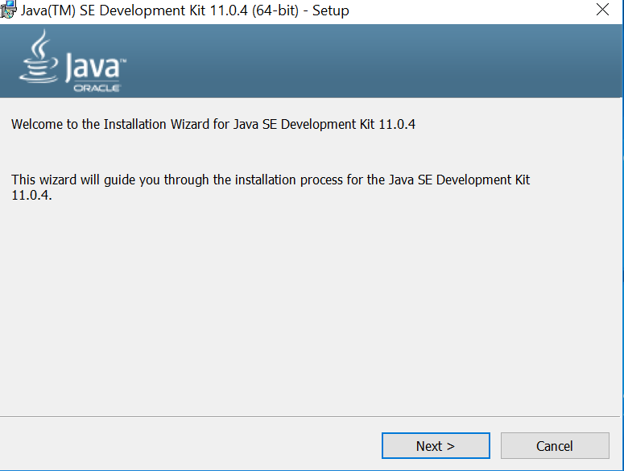

Make sure to specify the path: **D:\Java\jdk-11.0.4**

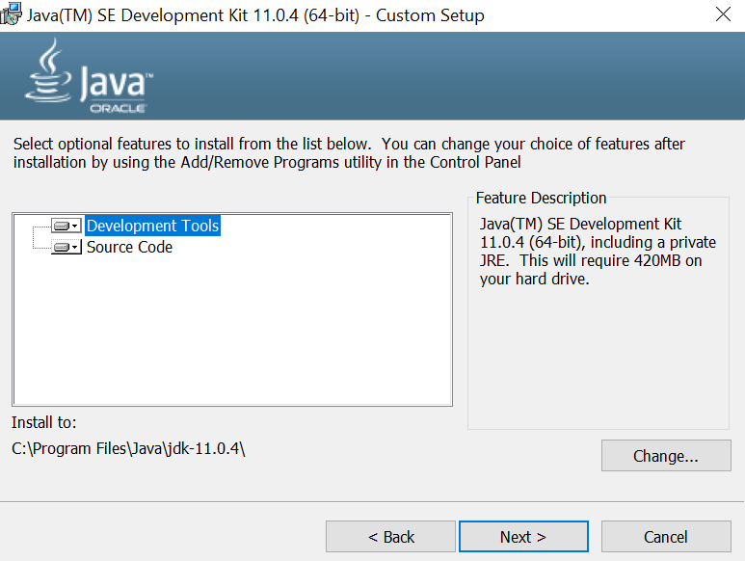

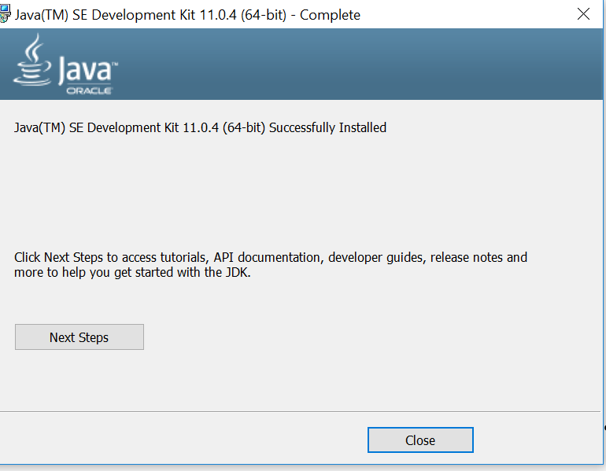

Set **environmental** variables:

JAVA_HOME D:\Java\jdk-11.0.4

JBOSS_HOME D:\Jboss

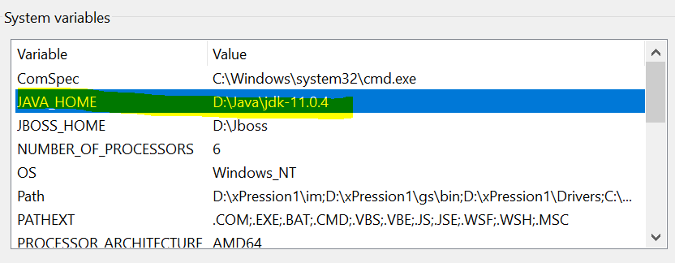

# Install JBOSS

Copy from \\mnepapp81-d\xPression\EPS_Team\xPression 4.7 Migration\Install

File name: jboss-eap-7.2.0-installer.jar

to D:\Software

Run jboss-eap-7.2.0-installer.jar

And install on D:\Jboss

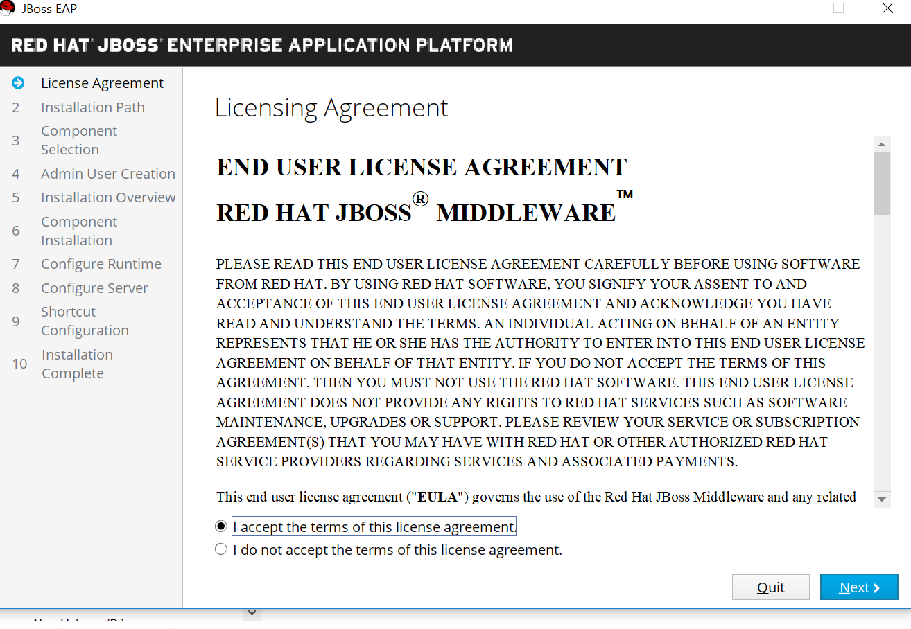

Make sure to select the right path: **D:\Jboss**

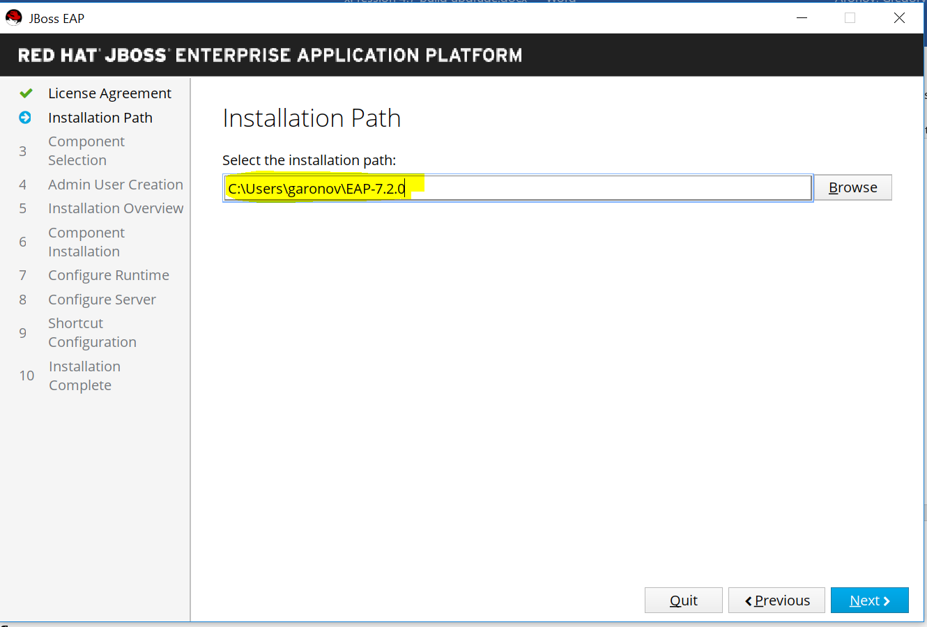

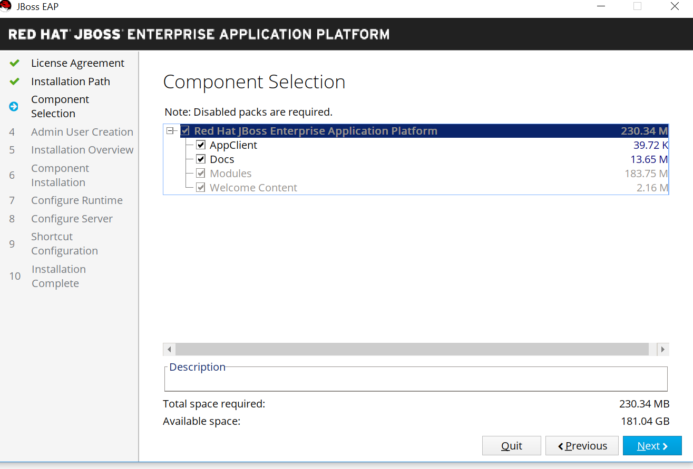

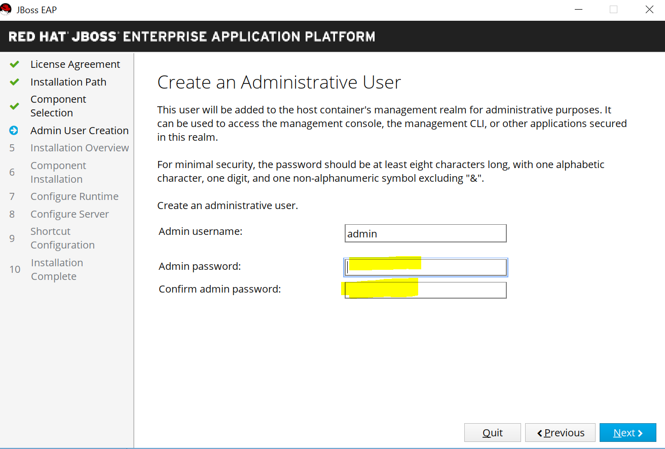

User name:

in DEV server **CORP\SVC-EPS-APP-DEV**

in TEST server **CORP\SVC-EPS-APP-TEST**

in PROD server **CORP\SVC-EPS-APP-PROD**

Password: please contact Brent Clennon at [Brent.Clennon@ltcg.com](mailto:Brent.Clennon@ltcg.com)

# Install SQL server driver

Copy from \\mnepapp81-d\xPression\EPS_Team\xPression 4.7 Migration\Install

File name: sqljdbc_7.2.2.0_enu.exe

to D:\Software

Run sqljdbc_7.2.2.0_enu.exe

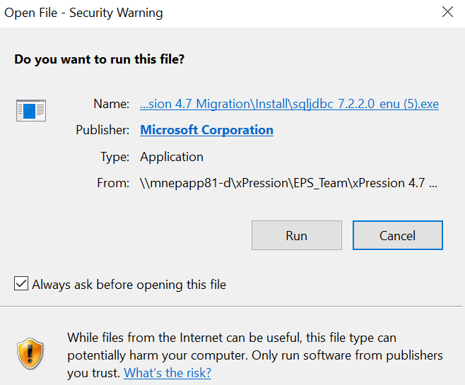

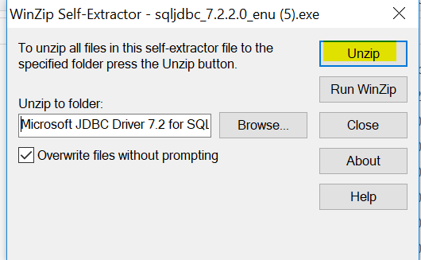

Click Unzip and use default location

# Install xPression server

**Note:** To prevent potential xPression production errors, verify that your system clock is set accurately

Before installing xPression.

Create a folder on the server:

D\xPression1

Copy 2 files to the folder: xPression.ear and xPression_Server_Installer_Windows.exe

From

\\mnepapp81-d\xPression\EPS_Team\xPression 4.7 Migration\Install

File name:xPression.ear

and

From

\\mnepapp81-d\xPression\EPS_Team\xPression 4.7 Migration\Install\xp47_b10_xpression_server_installer (2).zip

File name: xPression_Server_Installer_Windows.exe

Run xPression_Server_Installer_Windows.exe as Administrator

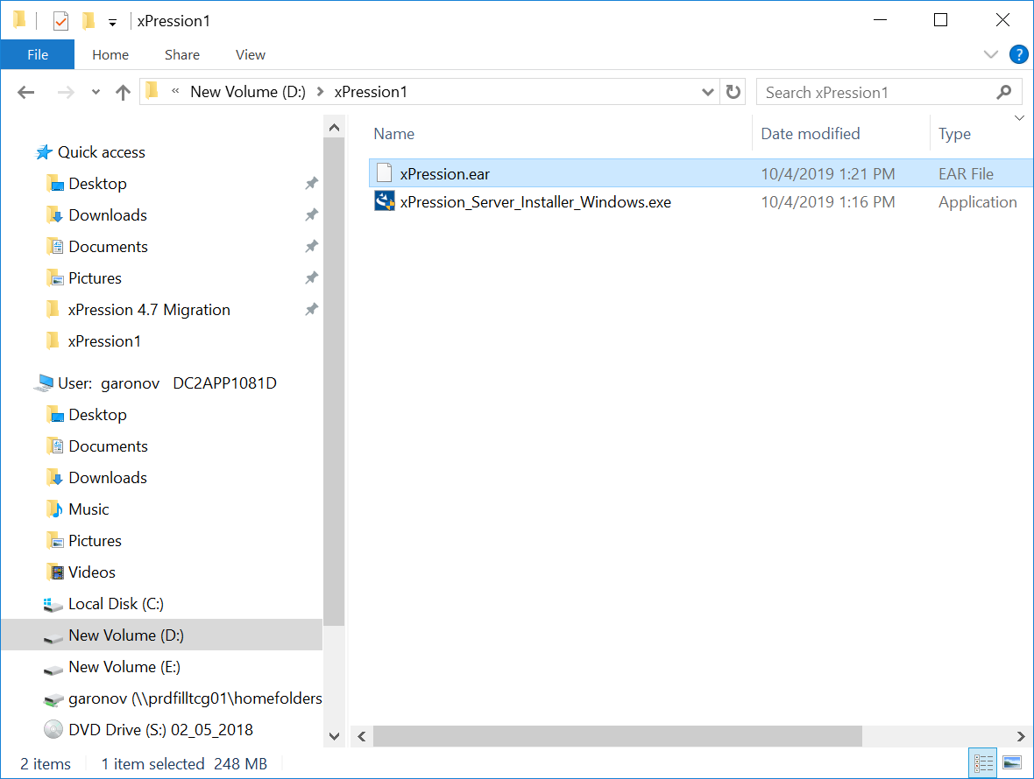

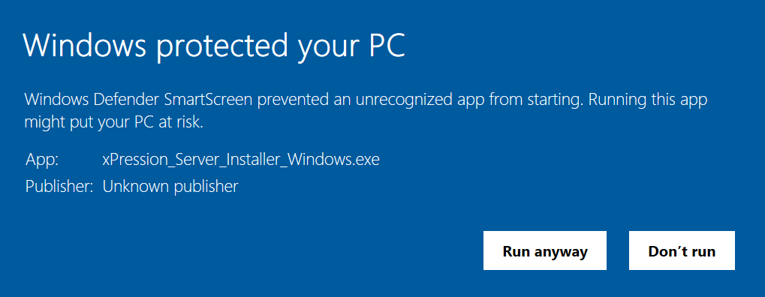

Click “Run anyway”

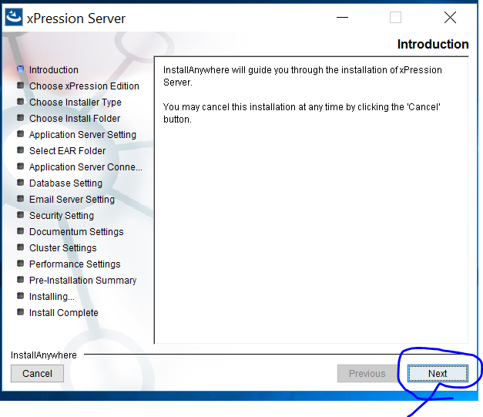

**Uncheck** Compuset

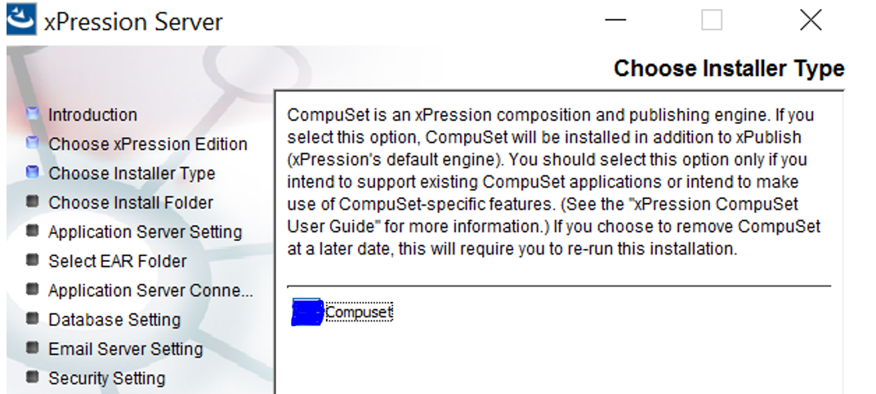

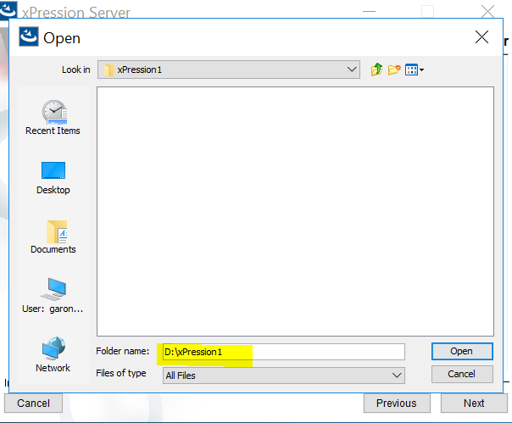

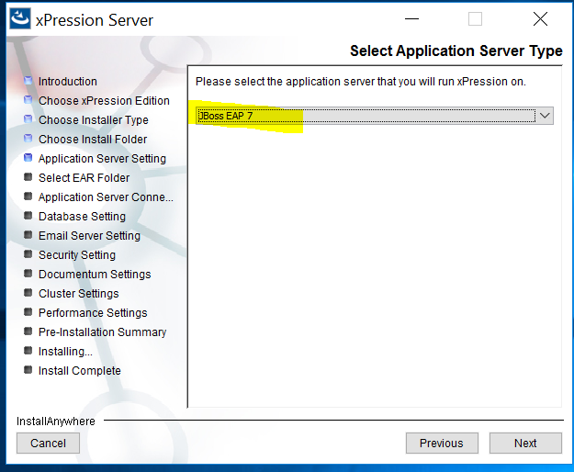

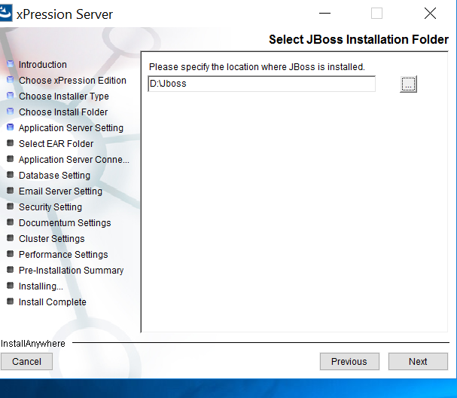

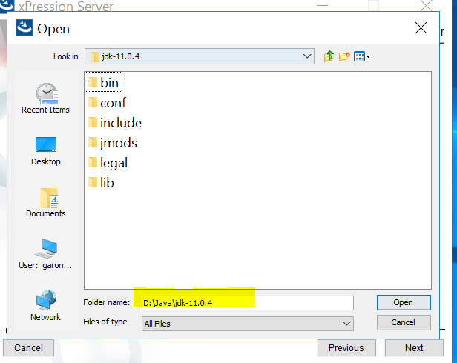

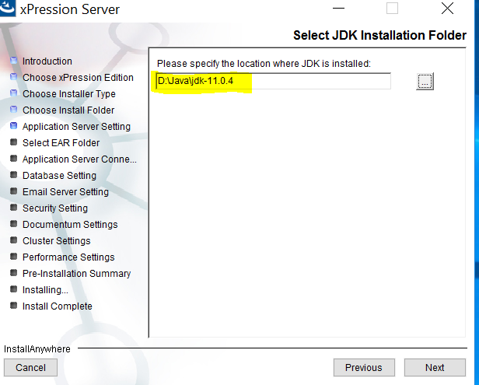

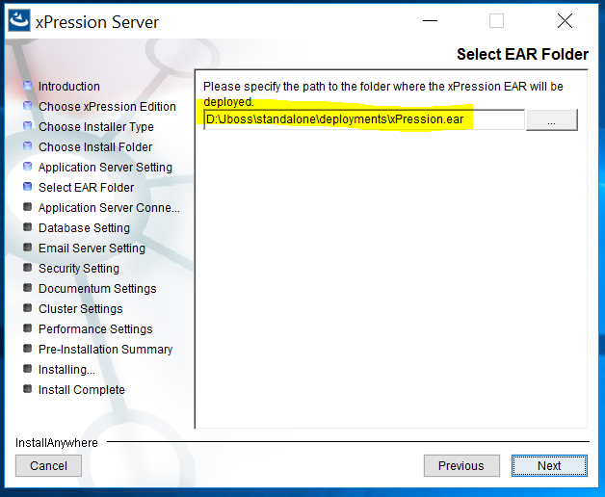

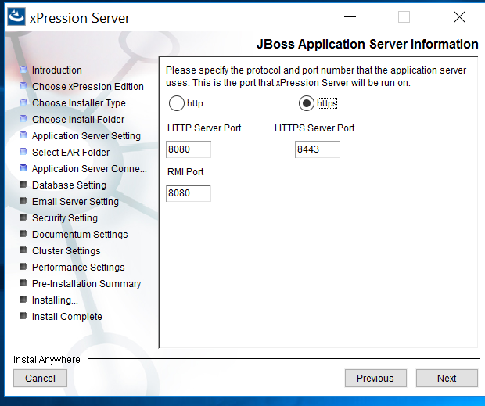

Descriptive name and Server Name: use server names

**App servers Names:**

DC2APP1081D for DEV

DC2APP1081T for TEST

DC1APP1081P for PROD

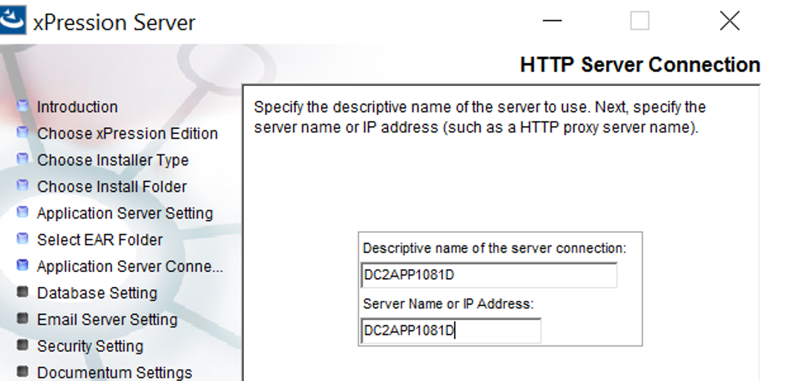

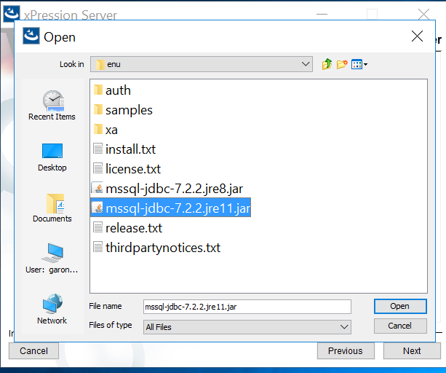

Path for sql server driver

D:\sqljdbc_7.2\enu\mssql-jdbc-7.2.2.jre11.jar

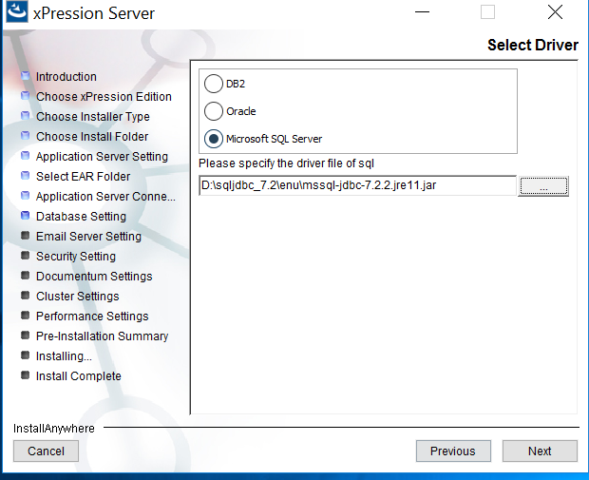

**SQL servers Names:**

DC2SQL1081D for DEV

DC2SQL1081T for TEST

DC1SQL1081P for PROD

Port Number: 1433

**Database Name:**

DEV1XPRESS for DEV

TST1XPRESS for TEST

PRD1XPRESS for PROD

User name and password: please contact Brent Clennon at [Brent.Clennon@ltcg.com](mailto:Brent.Clennon@ltcg.com)

**\*\*\*(BELOW PRINT SCREEN JUST A SAMPLE FROM DEV. Please replace server name and Database Name for each environment.)**

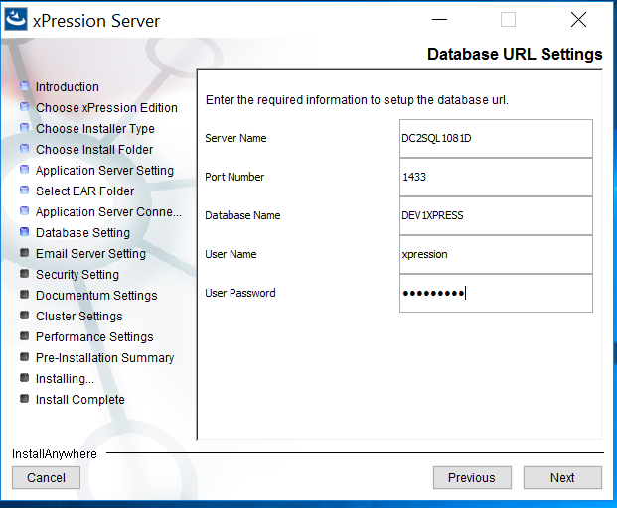

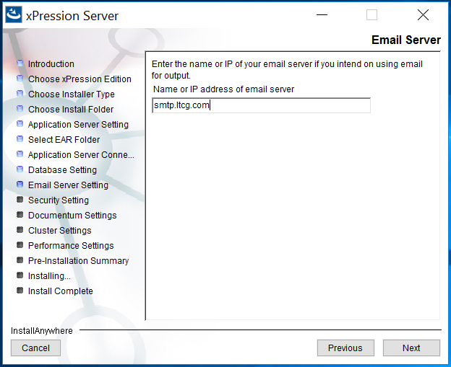

Choose **LDAP** authentication.

Enter in **test** for the password and click **Next**. (LDAP will be configured after the installation.

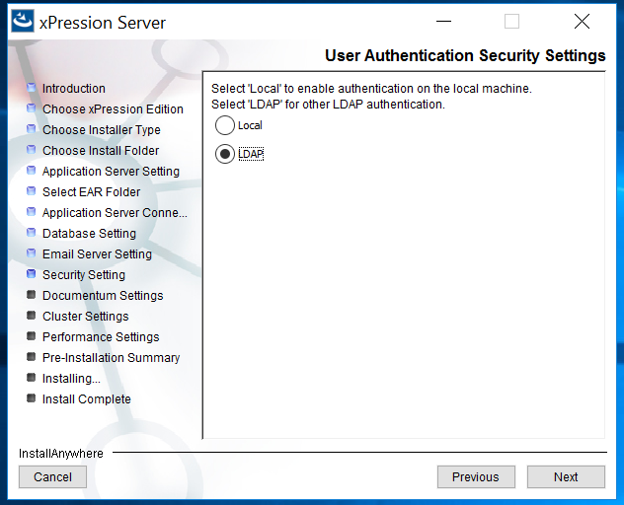

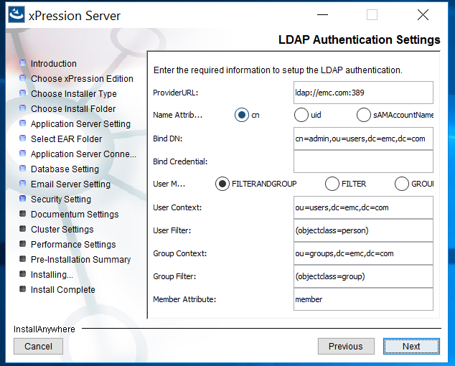

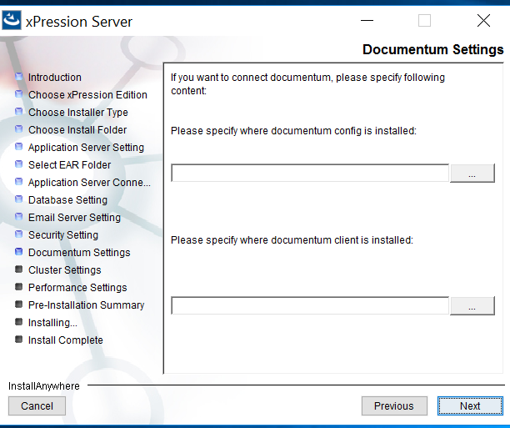

**The "Cluster Settings" Page**

• **Local** – xPression is configured to use Local cast by default. Use Local cast when xPression is

used in a single-server environment. xPression will only send messages to the local machine. To

configure xPression for Local cast, you don't have to do anything, xPression will be configured

upon installation.

**\*\*\*For LTCG use Local**

Click “Next”

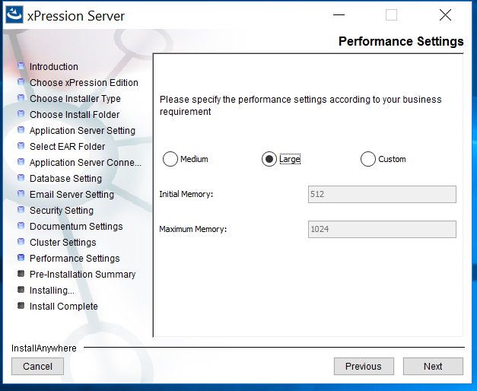

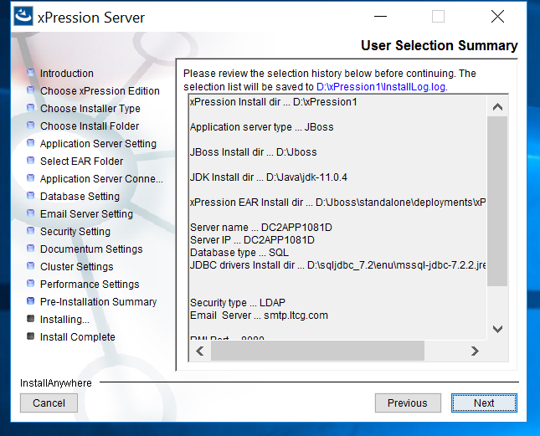

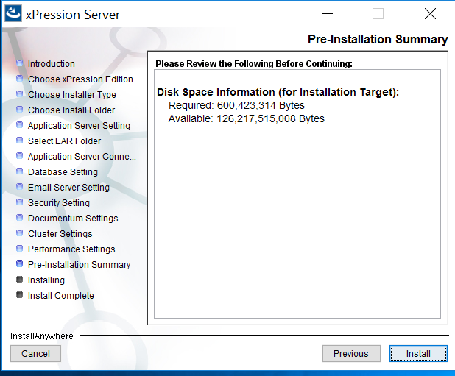

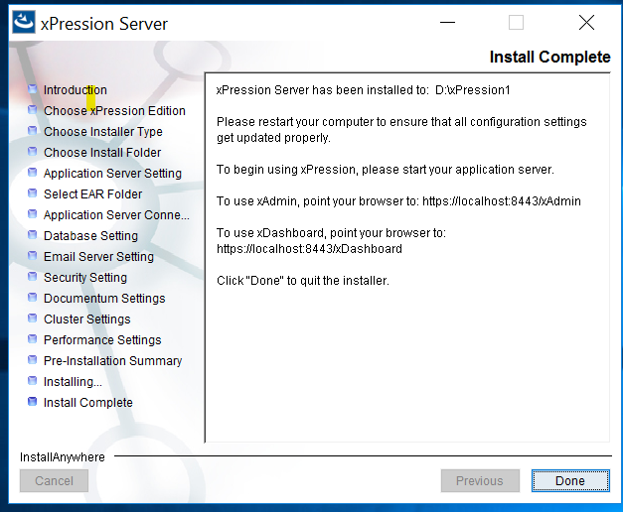

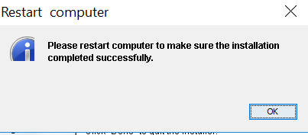

# Running as a windows service

* Extract jbcs-jsvc-1.1.0-win6-x86_64 to d:\jbcs-jsvc-1.1.  You should now have a path d:\jbcs-jsvc-1.1\bin. Verify this exists.
* In the Jboss bin directory, Create a copy of service.bat, call it xPressionService.bat.
* In xPressionService.bat, Update the path to jbcs-jsvc in the file to point to the correct folder.
  + I just replaced all occurrences of jbcs-jsvc-1.0 with jbcs-jsvc-1.1
* Open a command prompt as an administrator
* Navigate to the Jboss bin folder in command prompt
* Run the following command

xPressionService.bat install /startup /name JBoss_xPression1_Server /desc JBoss_xPression1_Server /config xpression-standalone.xml /loglevel INFO

* Run services.msc
* Verify the Jboss_xPression1_Server service exists
* Update the username and password for the service - see Brent Clennon at [Brent.Clennon@ltcg.com](mailto:Brent.Clennon@ltcg.com) for credentials.  Credentials are different between dev, test, and production. **DO NOT USE THE SAME CREDENTIALS IN EACH ENVIRONMENT**
* Start the service
* Verify the xPression server is running without issue

# How to restart JBOSS service

In order to restart

Login to the server, lunch Services, navigate to JBOSS_xPression1_Server

Click “Restart”

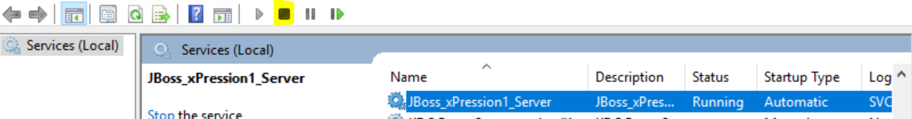

Sometimes it does not stop, workaround is to stop java.exe via Task Manager to end task for java.exe

Note: This issue has been fixed with opentext ticket with the steps in attached document below.

|  |
| --- |
|  |

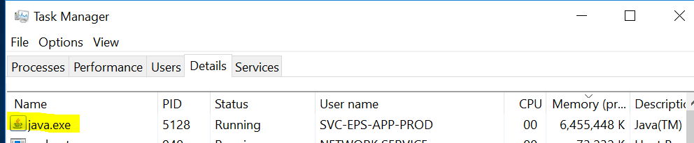



Then START service JBOSS_xPression1_Server

User name:

in DEV server **CORP\SVC-EPS-APP-DEV**

in TEST server **CORP\SVC-EPS-APP-TEST**

in PROD server **CORP\SVC-EPS-APP-PROD**

Password: contact Brent Clennon at [Brent.Clennon@ltcg.com](mailto:Brent.Clennon@ltcg.com)

# Update files:

D:\Jboss\bin\standalone.conf.bat

SET "JAVA_OPTS=-Xms8G -Xmx8G

D:\xPression1

BatchRunner.properties

BatchRunner.bat

**BatchRunner.bat** we set it to -Xms1024M -Xmx4096M

From Java_Option=-server -Xms512M -Xmx1024M

To Java_Option=-server -Xms8G -Xmx8G

Copy files from  D:\xPression1\CustomerData  from 4.5 to 4.7

From mnepapp81-d to

DC2APP1081D

DC2APP1081T

DC1APP1081P

Copy files from \\mnepapp81-d\xPression1\image

To

DC2APP1081D

DC2APP1081T

DC1APP1081P

D:\xPression1\image

***Updating files as per LTCG recomendation

|  |  |  |
| --- | --- | --- |
| **Filename** | **Comparison result** | **Changes needed to 4.7 file** |
| Bats | Left only: \\mnepapp81-p\xPression1 | Copy from respective 4.5 dev, test, or prod server |
| CustomerData |  | Copy from respective 4.5 dev, test, or prod server, except servers.xml |
| EPSUtil | Left only: \\mnepapp81-p\xPression1 | Copy from respective 4.5 dev, test, or prod server |
| Publish |  | Copy from respective 4.5 dev, test, or prod server |
| xBatchlog | Left only: \\mnepapp81-p\xPression1 | Copy from respective 4.5 dev, test, or prod server |
| BatchRunner.bat | Text files are different | -Xms1024M -Xmx4096M |
| BatchRunner.properties | Text files are different | ListenerFactoryImpClass = com.ltcg.userexit.LtcgLifeCycleListenerFactory  Java_Option=-server -Xms1024M -Xmx4096M |
| customerdata.properties | Text files are different | LTrim=true   RTrim=true |
| defaultMetaDataFormat.xml | Text files are different | Copy from respective 4.5 dev, test, or prod server |
| ldapcfg.properties | Text files are different | Copy from respective 4.5 dev, test, or prod server |
| LogConfiguration | Text files are different | Change to use DailyRollingFileAppender |

1. Edit d:\jboss\standalone\configuration\xpression-standalone.xml
2. Remove this section from the file:

                    <security>

  <user-name>xpression</user-name>

  <password>tpwpCXih</password>

                    </security>

1. Change the <connection-url>
   1. Add integratedSecurity=true;
   2. For **example**, for the dev server, it should look like this:

<connection-url>jdbc:sqlserver://DC2SQL1081D:1433;selectMethod=cursor;databaseName=DEV1XPRESS;integratedSecurity=true;</connection-url>

<connection-url>jdbc:sqlserver://DC2SQL1081T:1433;selectMethod=cursor;databaseName=TST1XPRESS;integratedSecurity=true;</connection-url>

<connection-url>jdbc:sqlserver://DC2SQL1081P:1433;selectMethod=cursor;databaseName=PRD1XPRESS;integratedSecurity=true;</connection-url>

This connection-url will be different between dev, test, and prod, as there will be difference sqlserver and databaseName values.

SQL servers Names:

DC2SQL1081D for DEV

DC2SQL1081T for TEST

DC1SQL1081P for PROD

DB names:

DEV1XPRESS for DEV

TST1XPRESS for TEST

PRD1XPRESS for PROD

1. Copy D:\sqljdbc_7.2\enu\auth\x64\sqljdbc_auth.dll to the following folders:
   1. d:\Java\jdk-11.0.4\bin
   2. d:\Java\jdk-11.0.4\lib

from Opentext recommendation to resolve the issue with error message “CSRF attack notice” on the xpression start up:

error message from xpression.log file:

2019-10-22 21:43:57 [default task-153] 514186863  WARN  root  - Detect a possible CSRF attack from 172.27.211.25 to request to /html/cm_summary.jsp

Edit this file:

D:\jboss\jboss-eap-7.2\standalone\deployments\xPression.ear\UniArch_Admin.war\WEB-INF\web.xml

Edit this to be false:

                                                <param-name>enableCSRFAttackProtection</param-name>

                                                <param-value>true</param-value>

1. Restart the xPression service
2. Verify no errors in jboss log
3. Verify that you can still get into xAdmin

Please work with infra to get the following access granted.  This is needed for the UW Summary job to run successfully.

# Access requests on the Servers

Following Access requests were completed with Infra:

Corp\svc-eps-app-dev needs read/write access to \\mnepapp03-t\DEVCapture

Corp\svc-eps-app-test needs read/write access to \\mnepapp03-t\TSTCapture

Corp\svc-eps-app-prod needs read/write access to \\mnepapp04-p\PRDCapture

Following groups were requested with Infra to provide the access and verify it is done correctly.

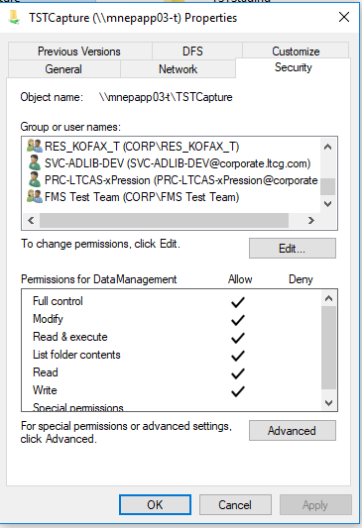

# License key update

Files saved under: \\mnepapp81-d\xPression\EPS_Team\xPression 4.7 Migration

LTCG xPression keys.zip

Login to xAdmin page for each environment:

<http://servername:8080/xAdmin/login.jsp>

Click on System Management, License Management

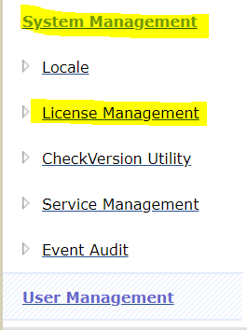

Click on Choose File

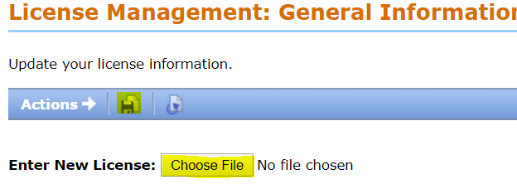

Browse to the license key file

Then click “SAVE”

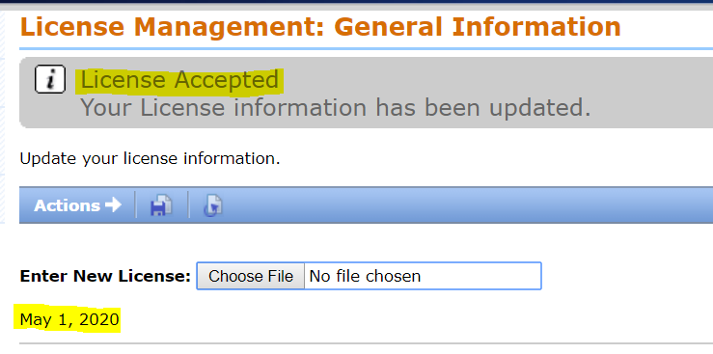

# Specific Fonts to be Installed

Following is the steps followed to install specific Fonts used

1. Remote desktop into <xpression server>
2. On <xpression server>, navigate to \\mnepapp81-t\c$\windows\fonts
3. Find CNAFont2
4. Right click on CNAFont2, select ‘install’.  This will install the font onto <xpression server>
5. Copy ImageMagick delegates configuration file from test to prod:
   1. Copy
   2. \\mnepapp81-t\xPression1\im\config\delegates.xml
   3. To
   4. \\<xpression server>\xPression1\im

# Shared folders

**\*\*\*The 4.7 server should have the same folder shares as the 4.5 server, with the same permissions granted.**

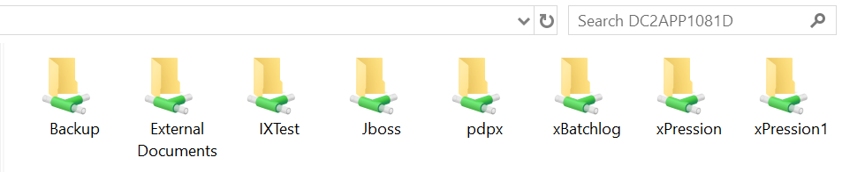

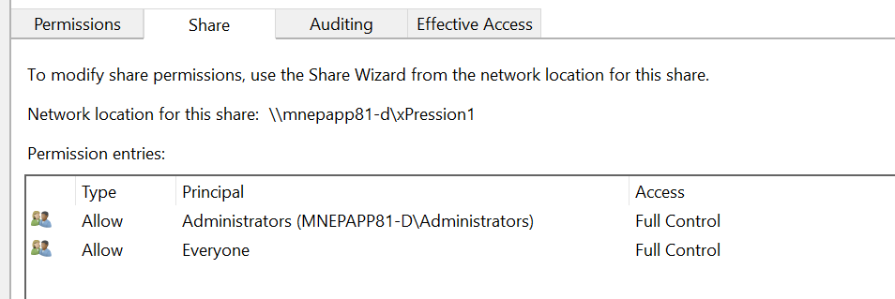

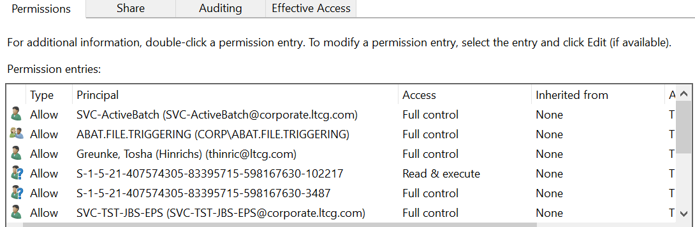

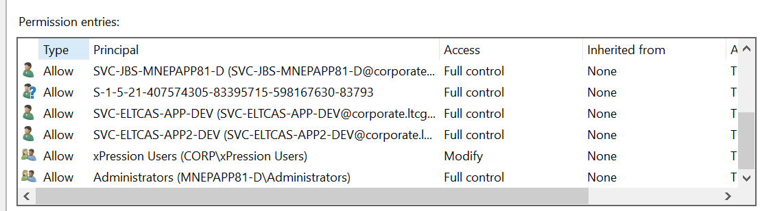

# Issues:

Login failed for user 'xpression' OTCS Ticket 4275483 - LTCG - xPression 4.7 Upgrade

**Resolution**: make sure xpression user have correct password

Sql server db:

User name: xpression

Password: see Brent

Unable to access the LDAP server. OTCS Ticket 4275483 - LTCG - xPression 4.7 Upgrade

**Resolution:** make sure ldap property file on xpression server is correct

OTCS Ticket 4281377 - LTCG - MS Word template for xPression 4.7

**Resolution:** Manually applied styles into new 4.7 templates

<https://knowledge.opentext.com/knowledge/cs.dll/kcs/kbarticle/view/KB11840264/customer/article.html>

*** you need have username and password to login to Opentext support site

OTCS Ticket 4748886 - LTCG - xAdmin 500 and blank screen errors

Here’s the fix:  <https://developer.jboss.org/thread/241526>

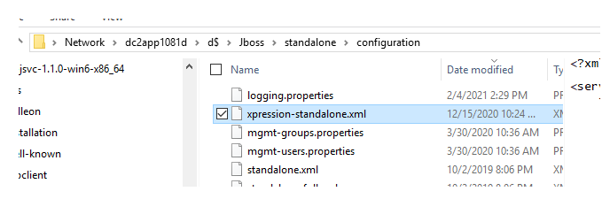

this one

 <http-listener name="default" socket-binding="http" max-post-size="104857600" redirect-socket="https" max-parameters="5000"/>

*** Update file as per LTCG recommendation

1. The user exit code can simply be copied from dev to test at the below respective locations:
   1. \\DC2APP1081D\d$\Jboss\standalone\lib\LtcgUserExit.jar
   2. \\DC2APP1081D\d$\Jboss\standalone\deployments\xPression.ear\lib\LtcgUserExit.jar
   3. \\DC2APP1081D\d$\xPression1\plugins\LtcgUserExit.jar

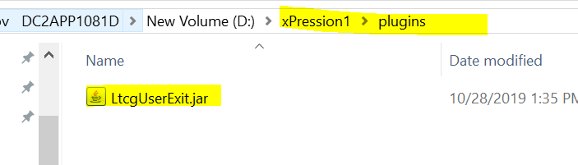

update BatchRunner.bat

1. In BatchRunner.bat, add the following at the end of the XPRESSION_JARS value:
   1. ;d:\Jboss\standalone\lib\*;%INSTALLPATH%\lib\LtcgUserExit.jar;
2. Add activation.jar to d:\Jboss\standalone\lib

# Issues encountered during Installation and Resolution:

#### Summary

When using xAdmin 4.6 with IE11, some UI elements appear to be disabled.

#### Resolution

There are a few options that can be specified in Internet Explorer to force it to use EDGE mode as opposed to Quirks mode:

* Turn off Compatibility Mode, and uncheck the option to display intranet sites in Compatibility Mode. Ensure that the URL that points to the URL 4.6 xAdmin is not in your list. Refer to the the following screen image:

#### Summary

Issue with external content pdf file where fonts slightly different

#### Resolution

Update Dcpi.properties file

Set DefaultResolution=300

Update xAdmin printer definition



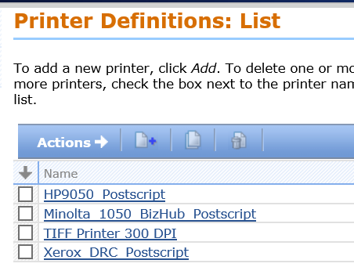

Unable to navigate xAdmin and Dashboard site via IE11 OTCS Ticket 4286967 : xAdmin in IE11

**Cause**

Internet Explorer 11 may revert to Quirks mode (legacy html) if it can not detect the document type being presented on a web page.

Reference: **Article ID:KB6308532**

#### This article Applies to following version of xPression

* Document Sciences xPression Documentum Edition 4.2, 4.5, 4.6
* Document Sciences xPression Enterprise Edition - Compuset Engine 4.2, 4.5, 4.6
* Document Sciences xPression Enterprise Edition - Publish Engine 4.2, 4.5, 4.6

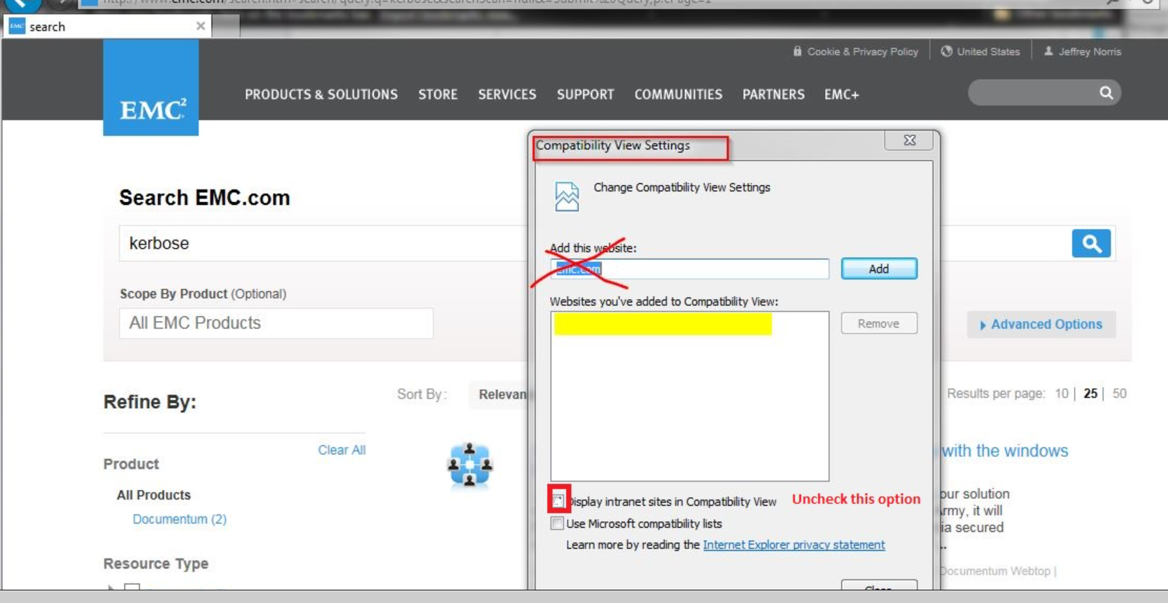

* Force EDGE mode using the developer options inside of Internet Explorer 11. Refer to the following screen image.  [Note: This mode may shift HTML elements or have text centered when it should not be.]

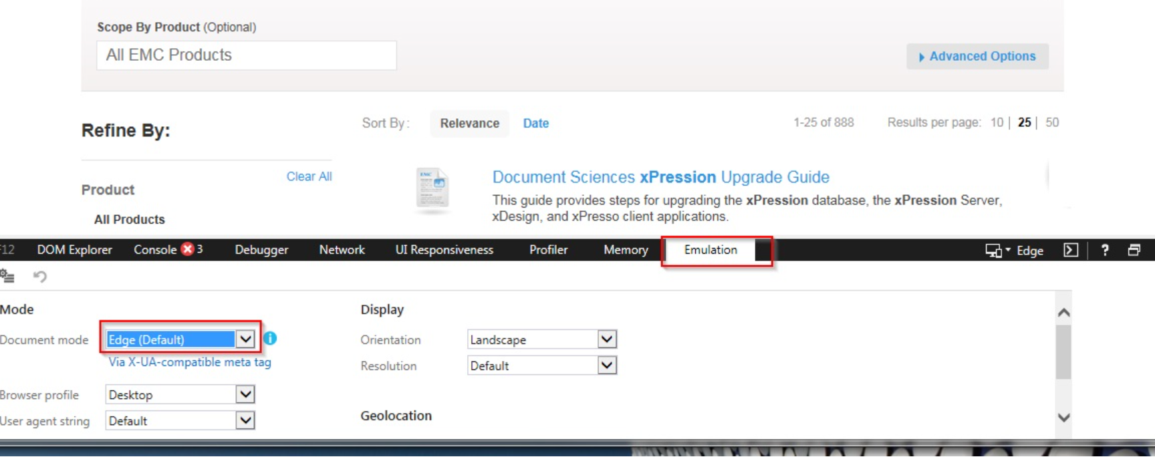

#### Summary

xPression - Output files contain a large number in the name of the file that did not exist previously

In xPression, document file names now contain a large number (GUID) instead of the customer ID. Previously, you would see the filename as doc_1234.pdf, however it now appears with the GUID in the name as follows, doc_1234_123456789012345.pdf

#### Resolution

This is not a defect with xPression 4.6 SP1 published documents. This behavior was added to include the customer record and the GUID for each customer record when the output document is created.

You can override this behavior by making a configuration change inside xPressionPublish.properties

Edit the file **xPressionPublish.properties** which is located in your xPressionHome directory on the xPression server e.g c:\xPression . /opt/xPression

Look for: IsOverWriteMetaDataFile=False

Change to: IsOverWriteMetaDataFile=True

Save xPressionPublish.properties

Run your output again and you should observer that the GUID is no longer part of the filename.

OTCS Ticket 4331821 : Content Item already locked by another user

Sometimes content item or rules locked.

In order to unlock please run the query below:

DB server: DC2SQL1081D

DB name: DEV1XPRESS

**DELETE FROM T_LOCK**

# Templates:

:  \\DC2APP1081D\xPression\Template\4.7

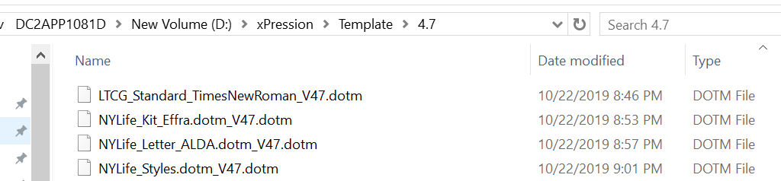

**File name:**LTCG_Standard_TimesNewRoman_V47.dotm

NYLife_Kit_Effra.dotm_V47.dotm

NYLife_Letter_ALDA.dotm_V47.dotm

NYLife_Styles.dotm_V47.dotm

All documents in xDesign needs to be regenerate xml, re-create a version document.

# New Changes from 4.5:

For the new changes done in 4.5 starting on Oct 1st 2019, EPS will manually do the changes again in 4.7 and move to TEST 4.7

EPS Developers will only make the changes in 4.7 DEV for the code that has be successfully unit tested and moved to 4.7 TEST. For the PPM tickets with ongoing work or open questions, changes will not be made.

EPS will follow the same process in V4.7 of exporting the code to TEST as its currently done in V4.5. See the steps below.

Step1: Make the necessary changes for the new PPM/ticket in V4.7 DEV.

Step2: Export the code and create PDPX files in PDPX folder of E Drive

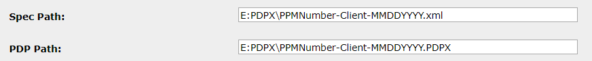

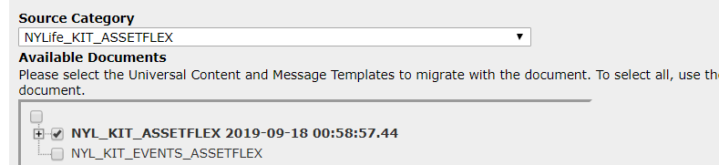

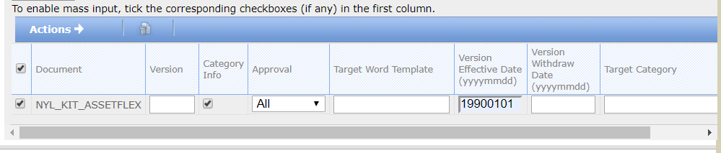

Step3: Drop the files in the below folder of 4.7 TEST env to import the code.

\\DC2APP1081T\xPression1\EPSUtil\AutoImport\Doc

# xDesign installation

Prior to installation please make sure you have:

Microsoft.net 4.7

jdk-11.0.4

MS Word for office 365

This is installed on xDesign

\\DC2APP1082D\xp47_b10_xdesign_installer

File name: setup.exe

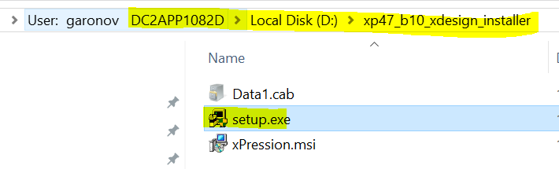

Click on “setup”

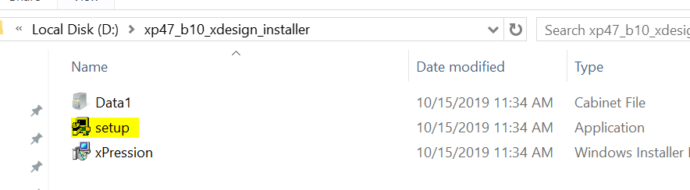

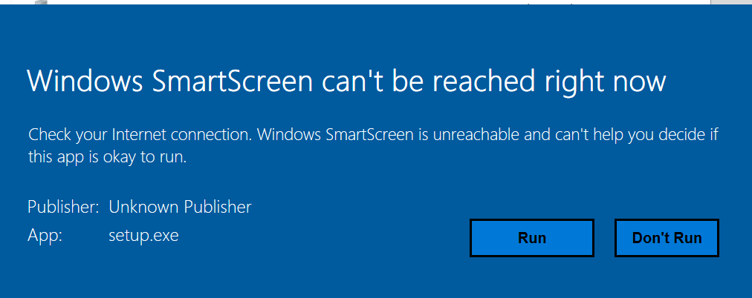

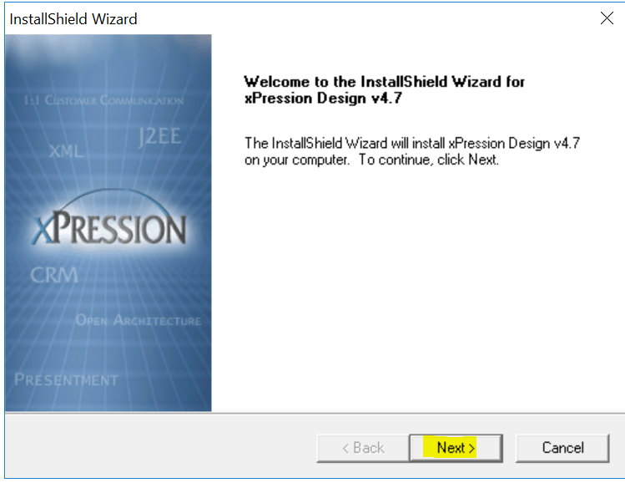

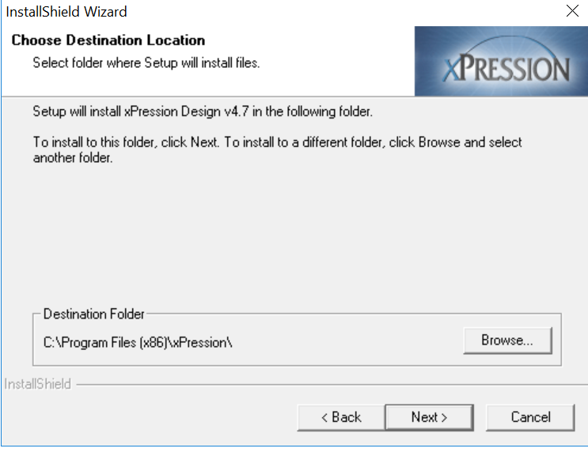

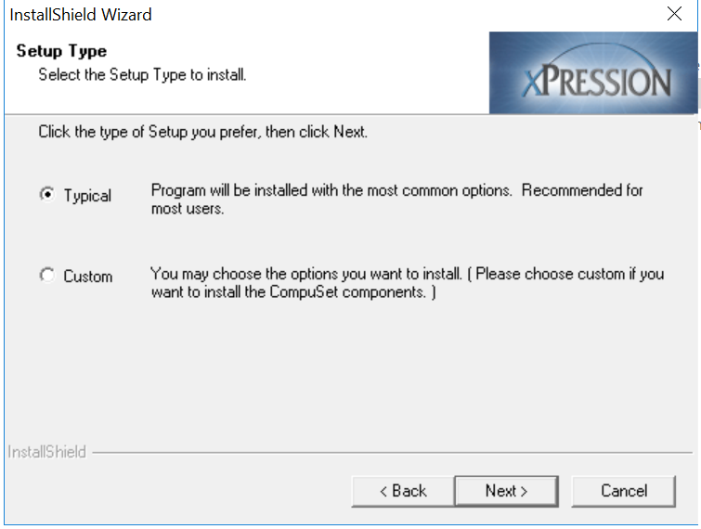

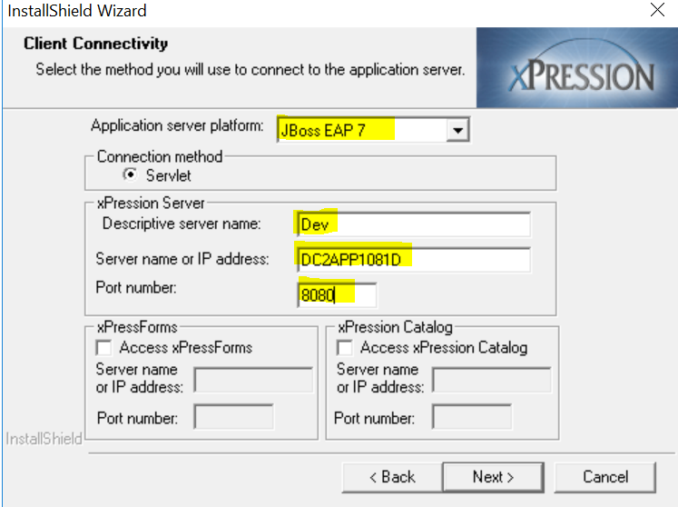

Make sure JDK installed prior to installation

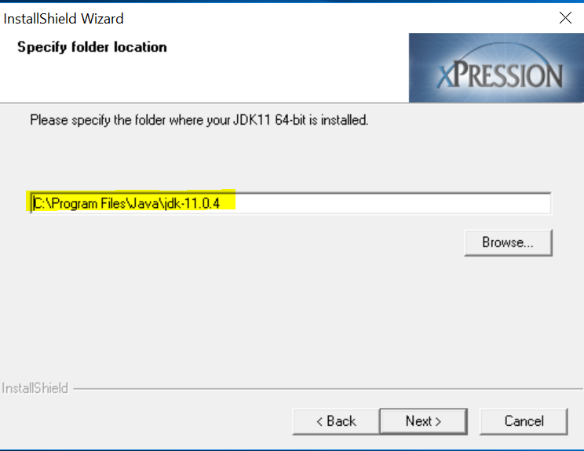

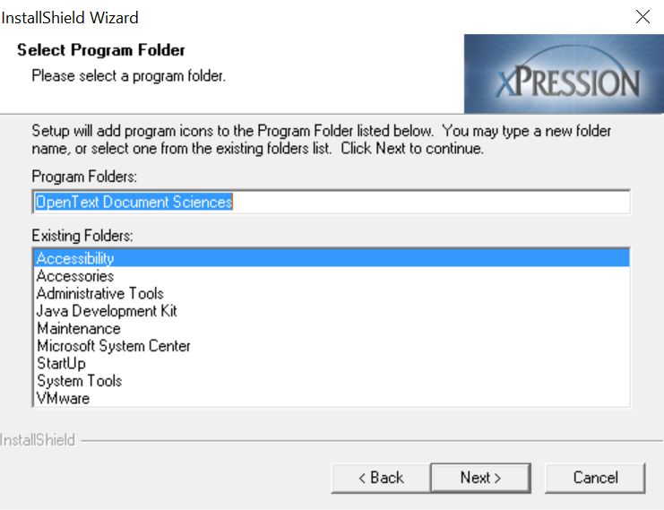

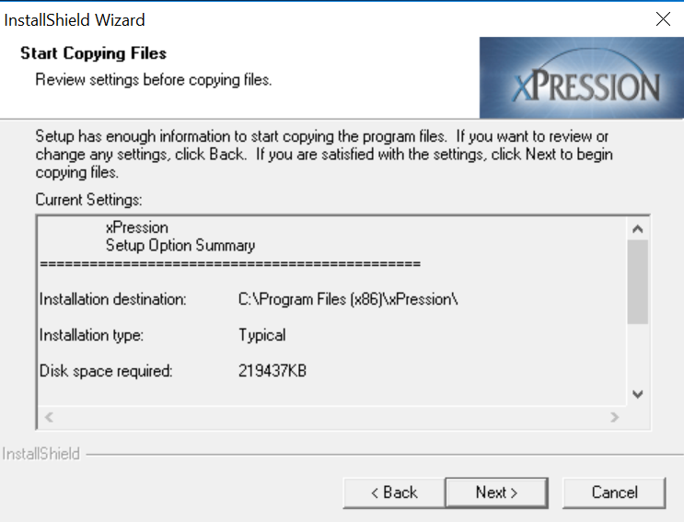

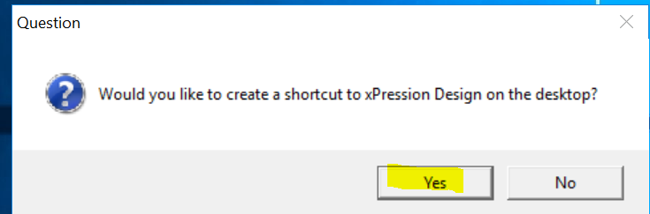

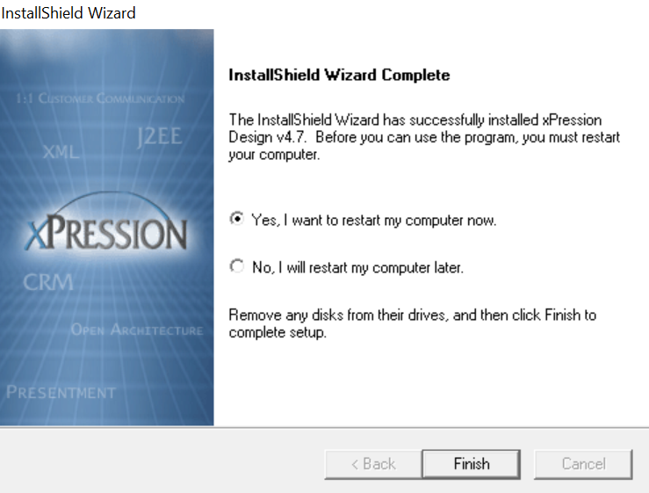

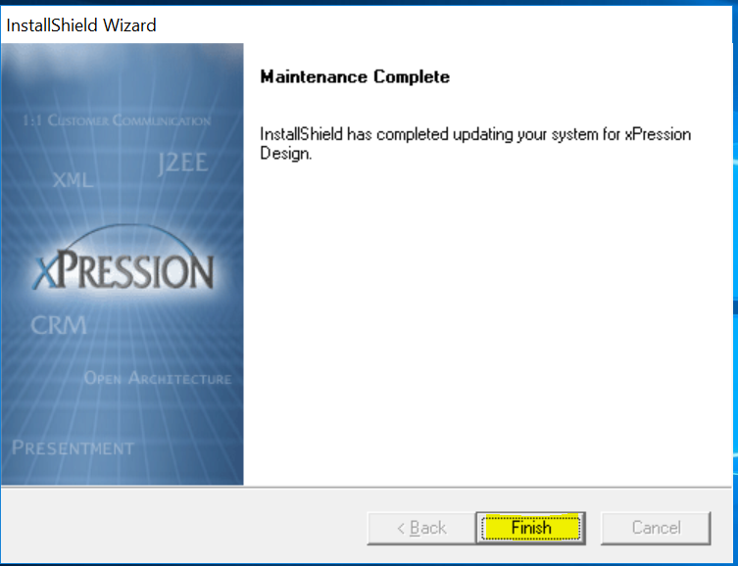

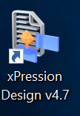

Template upgrade

Old or existing customized template

\\mnepapp81-d\xPression\Template\LTCG_Standard_TimesNewRoman.dotm

New default template Supplied with xDesign:

C:\Program Files (x86)\xPression\Design\Template\LTCGxPressionWordTemplate_V47.dotm

New custom template target path and file name:

C:\Templates\LTCG_Standard_TimesNewRoman.dotm

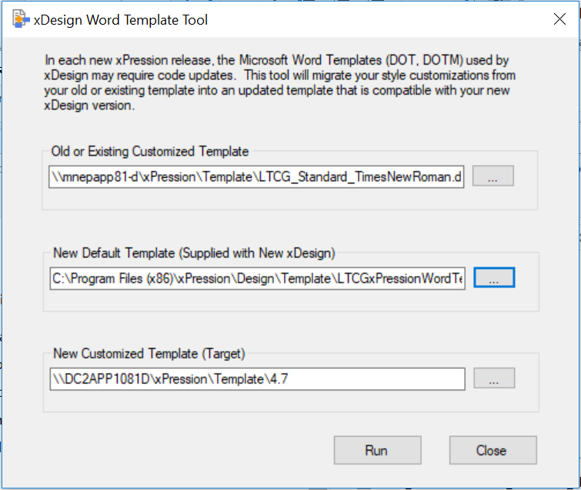



# xAdmin URLS

<http://DC2APP1081D:8080/xAdmin/> -->xAdmin 4.7 DEV

<http://DC1APP1081T:8080/xAdmin/> -->xAdmin 4.7 TEST

<http://DC1APP1081P:8080/xAdmin/> -->xAdmin 4.7 PROD

**Below steps were performed in all environments DEV/TEST/PROD to fix the issue of getting the images from C360 for New issue kits:**

1. Deployed the updated LtcgUserExit to DEV/TEST/PROD 4.7

2. Restart DEV/TEST/PROD 4.7

3. Latest LtcgUserExit.jar file were copied to below folders

\\dc2app1081d\d$\Jboss\standalone\lib

\\dc2app1081d\d$\xPression1\plugins

\\dc2app1081d\d$\Jboss\standalone\deployments\xPression.ear\lib

**Here is what additional step done to resolve the pulling Case360 image issue in 4.7**

1. Needed to put ntlmauth.dll in d:\Java\jdk-11.0.4\bin

a. Done in DEV/TEST/PROD of 4.7

2. Needed to put jtds-1.2.5.jar in d:\Jboss\standalone\deployments\xPression.ear\lib

a. Done in DEV/TEST/PROD of 4.7

3. Restarted DEV/TEST/PROD servers.